ASSIGNMENT-8

HT NO: 2403a52355

BATCHNO: 13

Prompt-1:
Generate a pyhton program contain at least 3 assert test cases for is_strong_password(password) and implement the validator function.

Code:
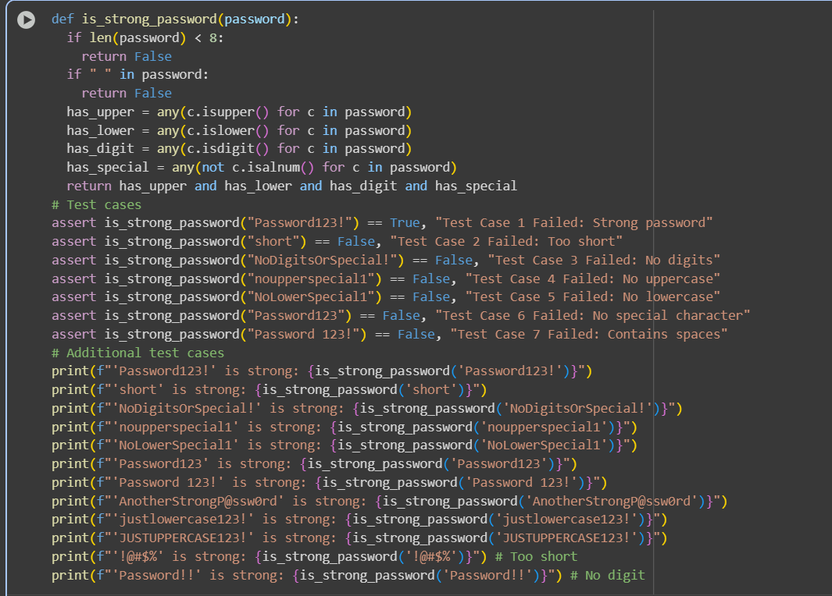

Output:
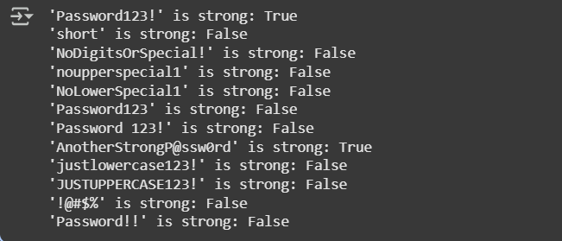

Explaination:
This code defines a Python function called is_strong_password that checks if a given password string meets certain criteria for being considered "strong".
Here's a breakdown:
- def is_strong_password(password):: This line defines the function named is_strong_password which takes one argument, password.
- if len(password) < 8:: This checks if the length of the password is less than 8 characters. If it is, the function immediately returns False, as the password is too short.
- if " " in password:: This checks if there is a space character anywhere in the password string. If a space is found, the function returns False, as spaces are not allowed.
- has_upper = any(c.isupper() for c in password): This line checks if the password contains at least one uppercase letter. It uses a generator expression (c.isupper() for c in password) which creates an iterator that yields True for each character that is uppercase and False otherwise. The any() function then returns True if at least one of the values from the iterator is True.
- has_lower = any(c.islower() for c in password): Similar to the previous line, this checks if the password contains at least one lowercase letter.
- has_digit = any(c.isdigit() for c in password): This checks if the password contains at least one digit (0-9).
- has_special = any(not c.isalnum() for c in password): This checks if the password contains at least one "special" character. c.isalnum() returns True if a character is alphanumeric (a letter or a digit). not c.isalnum() therefore returns True if a character is not alphanumeric (i.e., a special character). The any() function then checks if there's at least one non-alphanumeric character.
- return has_upper and has_lower and has_digit and has_special: This is the final check. The function returns True only if all of the conditions (uppercase, lowercase, digit, and special character) are met. If any of these are False, the entire expression is False, and the function returns False.
The code also includes several test cases using assert statements and print statements to demonstrate how the function works with different inputs and to verify its correctness. assert statements will raise an AssertionError if the condition after assert is False, which helps in identifying if the function is not behaving as expected for specific inputs. The print statements explicitly show the result (True or False) of calling the function with various example passwords.

Prompt-2:
Generate a python program that contain at least 3 assert test cases for a classify_number(n) function. Implement using loops.

Code:
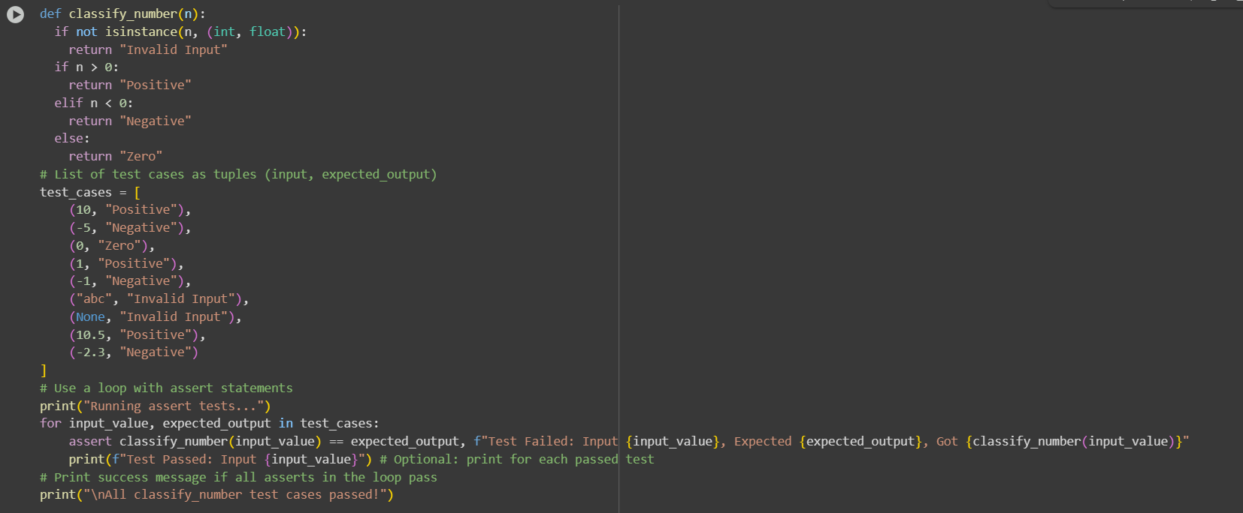

Output:
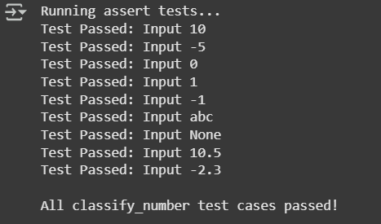

Explaination:
This code defines and tests the classify_number function, which determines if a given input is a positive number, a negative number, zero, or an invalid input.
Here's a breakdown:
- def classify_number(n):: This defines the function classify_number that takes one argument n.
- if not isinstance(n, (int, float)):: This checks if the input n is not an instance of either an integer (int) or a float (float). If it's any other type (like a string or None), it returns "Invalid Input".
- if n > 0:: If the input is a number (either int or float) and it's greater than 0, the function returns "Positive".
- elif n < 0:: If the input is a number and it's not greater than 0, this checks if it's less than 0. If true, it returns "Negative".
- else:: If the input is a number and it's neither greater than 0 nor less than 0, it must be 0. In this case, the function returns "Zero".
- test_cases = [...]: This creates a list of tuples. Each tuple represents a test case, containing an input value and the expected output classification for that input.
- print("Running assert tests..."): This simply prints a message to the console indicating that the test process is starting.
- for input_value, expected_output in test_cases:: This is a for loop that iterates through each tuple (test case) in the test_cases list. In each iteration, the input value is assigned to the variable input_value, and the expected classification is assigned to expected_output.
- assert classify_number(input_value) == expected_output, f"Test Failed: Input {input_value}, Expected {expected_output}, Got {classify_number(input_value)}": This is the core of the testing loop. For each test case:
  - It calls the classify_number function with the input_value.
  - It compares the actual result from the function call with the expected_output.
  - If the actual result does not equal the expected output, an AssertionError is raised, and the provided message (which includes the input, expected output, and actual output) is displayed. If the results match, the assert statement does nothing and the loop continues.
- print(f"Test Passed: Input {input_value}"): This line is inside the loop and will print a confirmation message for each test case that successfully passes the assert check.
- print("\nAll classify_number test cases passed!"): This line is outside the loop. It will only be reached and executed if the for loop completes without any AssertionError being raised. This message confirms that all the test cases in the test_cases list passed successfully.

Prompt-3:
Generate a pyhton program contain least 3 assert test cases for is_anagram(str1, str2) and implement the function.

Code:
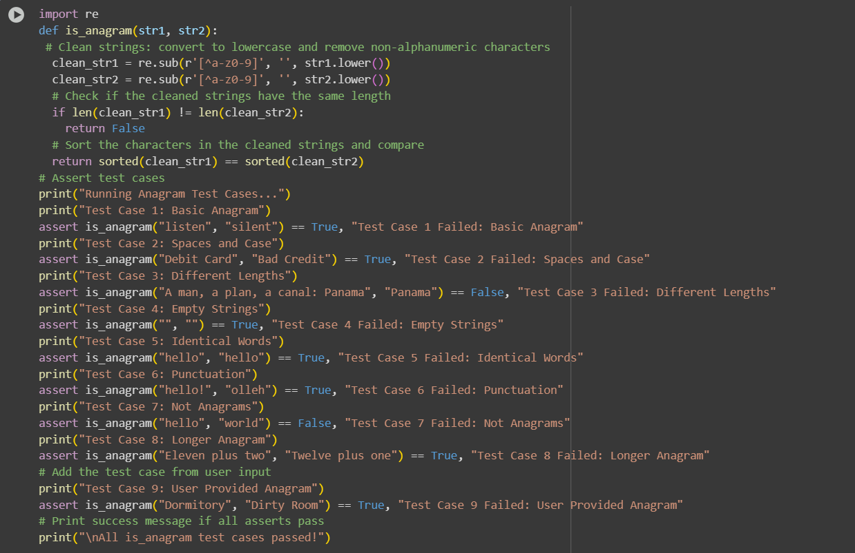

Output:
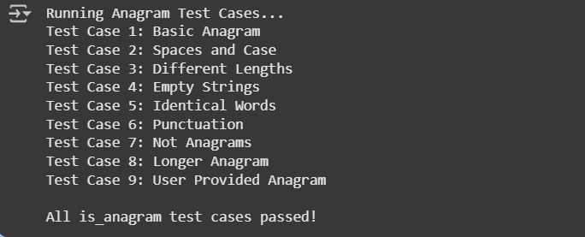

Explaination:
This code defines a Python function called is_anagram that checks if two input strings are anagrams of each other. Anagrams are words or phrases formed by rearranging the letters of a different word or phrase. The function is designed to ignore differences in case, spaces, and punctuation when making this determination.
Here's a breakdown:
- import re: This line imports the re module, which provides support for regular expressions. This module is used here for cleaning the input strings.
- def is_anagram(str1, str2):: This defines the function is_anagram which takes two string arguments, str1 and str2.
- clean_str1 = re.sub(r'[^a-z0-9]', '', str1.lower()): This line cleans the first input string (str1):
  - str1.lower(): Converts the entire string to lowercase to handle case-insensitivity.
  - re.sub(r'[^a-z0-9]', '', ...): This uses a regular expression substitution.
    - r'[^a-z0-9]': This is the regular expression pattern. [^...] is a negated character set, meaning it matches any single character that is not in the set. a-z matches lowercase letters, and 0-9 matches digits. So, this pattern matches any character that is not a lowercase letter or a digit.
    - '': This is the replacement string. It's an empty string, meaning any character matched by the pattern will be removed.
  - The result is a new string clean_str1 containing only lowercase letters and digits from the original str1, with spaces and punctuation removed.
- clean_str2 = re.sub(r'[^a-z0-9]', '', str2.lower()): This does the same cleaning process for the second input string (str2).
- if len(clean_str1) != len(clean_str2):: After cleaning, this checks if the lengths of the two cleaned strings are different. If they are, the strings cannot be anagrams, so the function immediately returns False.
- return sorted(clean_str1) == sorted(clean_str2): This is the core logic for checking if the cleaned strings are anagrams:
  - sorted(clean_str1): This sorts the characters in clean_str1 alphabetically and returns a list of characters.
  - sorted(clean_str2): This does the same for clean_str2.
  - ... == ...: This compares the two sorted lists of characters. If the strings are anagrams (ignoring case, spaces, and punctuation), they will contain the exact same characters with the same frequencies, so their sorted lists of characters will be identical, and this comparison will return True. Otherwise, it returns False.
The code also includes several assert test cases to verify that the is_anagram function works correctly for various scenarios, including basic anagrams, strings with spaces and different cases, strings with different lengths, empty strings, identical words, strings with punctuation, non-anagrams, and longer anagrams. The print statements before each assert help to indicate which test is currently being run, and the final print statement confirms that all the defined tests passed successfully without raising an AssertionError.

Prompt-4:
Generate a pyhton program contain at least 3 assert-based tests for an Inventory class with stock management

Code:
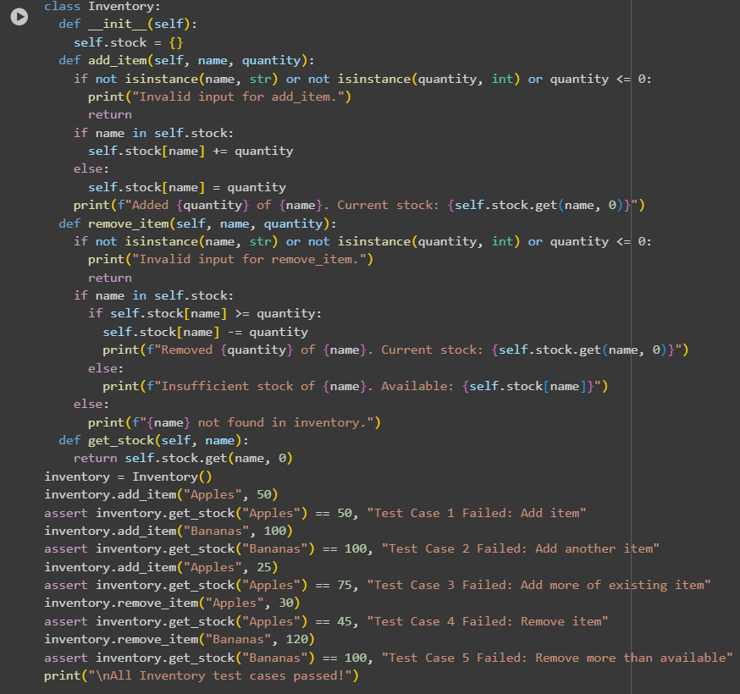

Output:
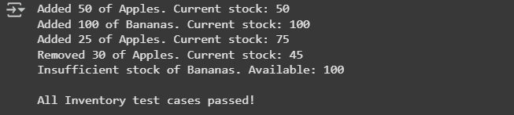

Explaination:
This code defines a Python class called Inventory to simulate a simple inventory management system. It allows you to add items, remove items, and check the current stock of a specific item.
Here's a breakdown of the class and its methods:
- class Inventory:: This line defines the Inventory class.
- def __init__(self):: This is the constructor method for the class. It's called automatically when you create a new Inventory object.
  - self.stock = {}: This initializes an empty dictionary called stock as an attribute of the Inventory object. This dictionary will be used to store the inventory. The keys of the dictionary will be the names of the items (strings), and the values will be the quantities of those items (integers).
- def add_item(self, name, quantity):: This method is used to add a specified quantity of an item with the given name to the inventory.
  - if not isinstance(name, str) or not isinstance(quantity, int) or quantity <= 0:: This checks if the inputs are valid. It ensures that name is a string, quantity is an integer, and quantity is greater than 0. If any of these conditions are not met, it prints an "Invalid input" message and the method returns without adding the item.
  - if name in self.stock:: This checks if the item name already exists as a key in the stock dictionary.
    - self.stock[name] += quantity: If the item exists, the provided quantity is added to the current stock of that item.
  - else:: If the item does not exist in the stock dictionary, it means it's a new item.
    - self.stock[name] = quantity: The new item is added to the stock dictionary with the specified initial quantity.
  - print(f"Added {quantity} of {name}. Current stock: {self.stock.get(name, 0)}"): This line prints a confirmation message showing how much of the item was added and the updated stock. self.stock.get(name, 0) safely gets the stock of the item, returning 0 if it's not found (although at this point in the logic, the item is guaranteed to be in self.stock if the input was valid).
- def remove_item(self, name, quantity):: This method is used to remove a specified quantity of an item with the given name from the inventory.
  - if not isinstance(name, str) or not isinstance(quantity, int) or quantity <= 0:: Similar to add_item, this checks for valid input types and ensures quantity is greater than 0.
  - if name in self.stock:: This checks if the item exists in the inventory.
    - if self.stock[name] >= quantity:: If the item exists, this checks if there is enough stock to remove the requested quantity.
      - self.stock[name] -= quantity: If there's enough stock, the quantity is subtracted from the item's stock.
      - print(f"Removed {quantity} of {name}. Current stock: {self.stock.get(name, 0)}"): Prints a confirmation of the removal and the updated stock.
    - else:: If there is not enough stock.
      - print(f"Insufficient stock of {name}. Available: {self.stock[name]}"): Prints a message indicating insufficient stock and the available quantity.
  - else:: If the item does not exist in the inventory.
    - print(f"{name} not found in inventory."): Prints a message indicating that the item was not found.
- def get_stock(self, name):: This method returns the current stock quantity for the item with the given name.
  - return self.stock.get(name, 0): This uses the get() method of the dictionary. It attempts to retrieve the value associated with the key name. If the key exists, it returns the corresponding value (the stock quantity). If the key does not exist (the item is not in the inventory), it returns the default value specified, which is 0 in this case.
Below the class definition, there are assert-based test cases:
- inventory = Inventory(): An instance of the Inventory class is created.
- The subsequent lines demonstrate using the add_item, remove_item, and get_stock methods and use assert statements to verify that the inventory's state (the stock quantities) matches the expected results after each operation. If an assert statement fails, it will raise an AssertionError with the provided message, indicating an issue in the code.
- Some lines also call remove_item with quantities exceeding the available stock or for items not in the inventory to show the printed messages for those scenarios.
- print("\nAll Inventory test cases passed!"): This message is printed only if all the assert statements execute without raising an error, confirming that the tests passed.

Prompt-5:
Generate a pyhton program contain to generate at least 3 assert test cases for validate_and_format_date(date_str) to check and convert dates.

Code:
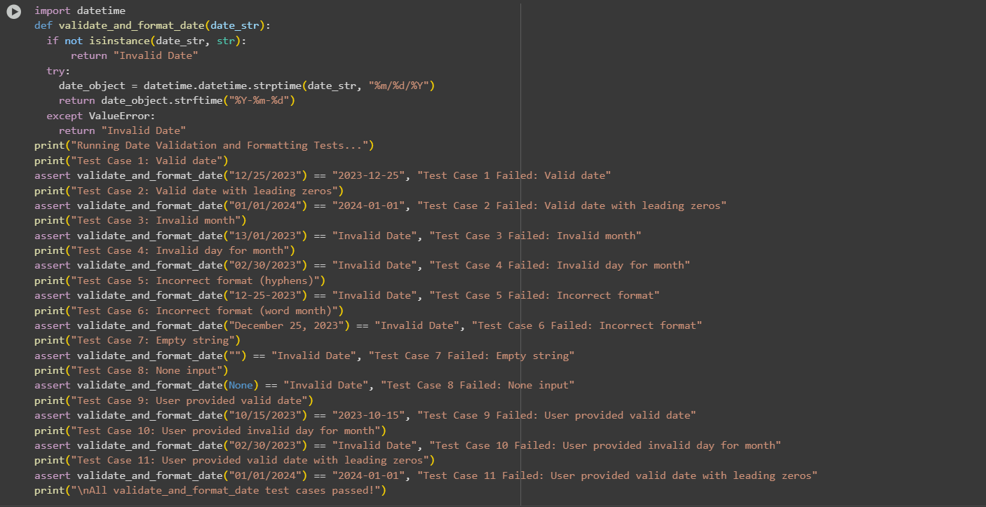

Output:
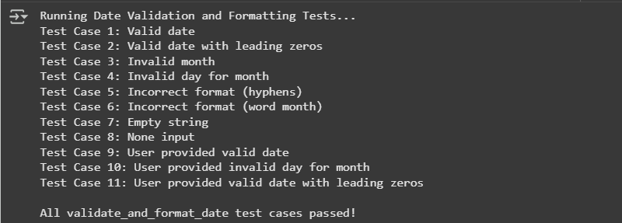

Explaination:
This code defines a Python function called validate_and_format_date that takes a string as input and attempts to validate if it's a date in the "MM/DD/YYYY" format. If it's a valid date in that format, it converts and returns it in "YYYY-MM-DD" format. Otherwise, it returns "Invalid Date".
Here's a breakdown:
- import datetime: This line imports the datetime module, which provides classes for working with dates and times.
- def validate_and_format_date(date_str):: This defines the function validate_and_format_date which takes one argument, date_str.
- if not isinstance(date_str, str):: This checks if the input date_str is not a string. If it's not a string (e.g., it's None, an integer, etc.), the function immediately returns "Invalid Date".
- try:: This starts a try block, which is used to handle potential errors that might occur during the code execution within the block.
- date_object = datetime.datetime.strptime(date_str, "%m/%d/%Y"): This is the core validation and parsing step. datetime.datetime.strptime() attempts to parse the input date_str according to the specified format string "%m/%d/%Y".
  - %m: Represents the month as a zero-padded decimal number (e.g., 01, 12).
  - %d: Represents the day of the month as a zero-padded decimal number (e.g., 01, 31).
  - %Y: Represents the year with century as a decimal number (e.g., 2023).
  - If the date_str successfully matches this format and represents a valid calendar date, strptime returns a datetime object.
- return date_object.strftime("%Y-%m-%d"): If the strptime call in the try block is successful, this line is executed. strftime() is used to format a datetime object into a string according to a specified format.
  - %Y: Represents the year with century.
  - %m: Represents the month.
  - %d: Represents the day.
  - This converts the valid date into the "YYYY-MM-DD" format and the function returns this formatted string.
- except ValueError:: If the strptime call fails because the input string does not match the "%m/%d/%YYYY" format or represents an invalid date (like "02/30/2023"), a ValueError exception is raised. This except block catches that specific exception.
- return "Invalid Date": If a ValueError is caught, the function returns the string "Invalid Date".
The code also includes several assert-based test cases with print statements before each assert to show which test is running. These tests cover various scenarios like valid dates (with and without leading zeros), invalid months, invalid days for a month, incorrect formats (using hyphens or word months), empty strings, and None input. The assert statements check if the function's output for each input matches the expected result. If all asserts pass without raising an error, the final print("\nAll validate_and_format_date test cases passed!") message is displayed.

